

**LAB-11**

By-Arun Lal



Sec-E

BSCS(II)

CMS-ID=023-24-0120

Exercise of Lab: 11

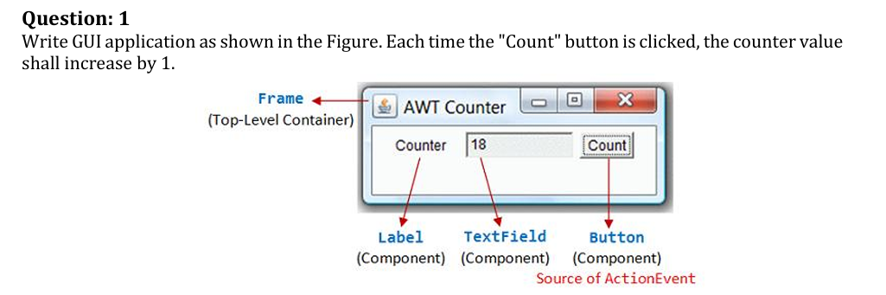

Code

import java.awt.*;

import java.awt.event.*;

public class AWTCounter extends Frame {

private Label lblCount;

private TextField tfCount;

private Button btnCount;

private int count = 0;

public AWTCounter () {

setLayout(new FlowLayout());

lblCount = new Label("Counter");

add(lblCount);

tfCount = new TextField(count + "", 10);

tfCount.setEditable(false);

add(tfCount);

btnCount = new Button("Count");

add(btnCount);

btnCount.addActionListener(new BtnCountListener());

setTitle("AWT Counter"); // "super" Frame sets its title

setSize(300, 100); // "super" Frame sets its initial window size

);

setVisible(true); // "super" Frame shows

}

// The entry main() method

public static void main(String[] args) {

AWTCounter app = new AWTCounter();

}

// Define an inner class to handle the "Count" button-click

private class BtnCountListener implements ActionListener {

// ActionEvent handler - Called back upon button-click.

@Override

public void actionPerformed(ActionEvent evt) {

++count; // Increase the counter value

// Display the counter value on the TextField tfCount

tfCount.setText(count + ""); // Convert int to String

}

}

}

Output

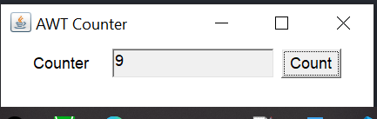

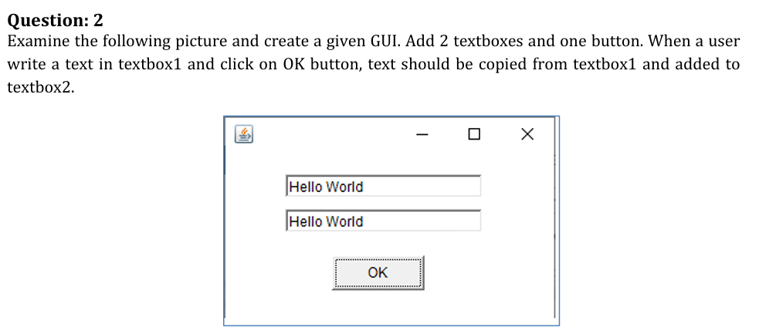

Code

import javax.swing.*;

import java.awt.event.*;

public class TextBoxCopy {

public static void main(String[] args) {

JFrame f=new JFrame();

JTextField t1=new JTextField();

t1.setBounds(50,50,200,30);

JTextField t2=new JTextField();

t2.setBounds(50,100,200,30);

JButton b=new JButton("OK");

b.setBounds(100,150,80,30);

b.addActionListener(new ActionListener(){

public void actionPerformed(ActionEvent e){

String text=t1.getText();

t2.setText(text);

}

});

f.add(t1); f.add(t2); f.add(b);

f.setSize(300,300);

f.setLayout(null);

f.setVisible(true);

f.setDefaultCloseOperation(JFrame.EXIT_ON_CLOSE);

}

}

Output

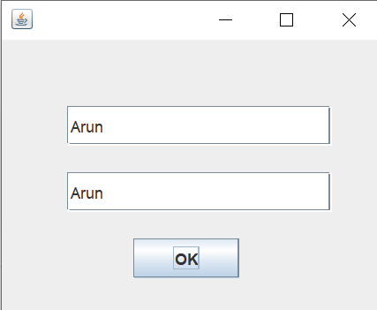

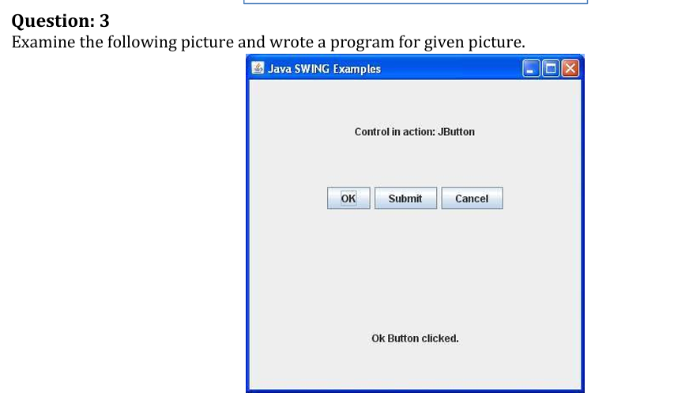

Code

import javax.swing.*;

import java.awt.*;

import java.awt.event.*;

public class JButtonExample {

public static void main(String[] args) {

JFrame f=new JFrame("Java SWING Examples");

final JLabel label = new JLabel();

label.setBounds(50,150,300,30);

JButton b1=new JButton("OK");

b1.setBounds(50,100,70,30);

JButton b2=new JButton("Submit");

b2.setBounds(130,100,90,30);

JButton b3=new JButton("Cancel");

b3.setBounds(230,100,90,30);

JLabel heading = new JLabel("Control in action: JButton");

heading.setBounds(50,50,200,30);

f.add(heading);

f.add(b1); f.add(b2); f.add(b3); f.add(label);

b1.addActionListener(new ActionListener(){

public void actionPerformed(ActionEvent e){

label.setText("Ok Button clicked.");

}

});

f.setSize(400,300);

f.setLayout(null);

f.setVisible(true);

f.setDefaultCloseOperation(JFrame.EXIT_ON_CLOSE);

}

}

Output

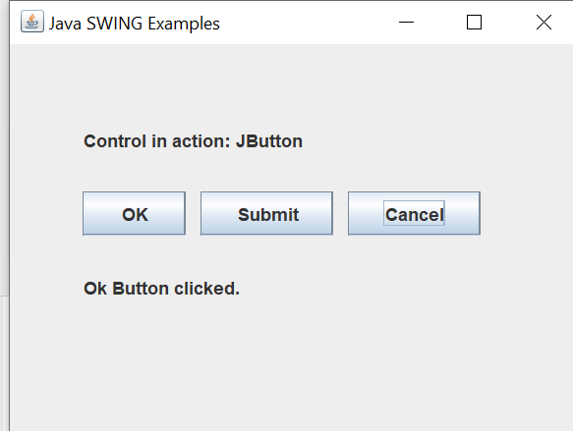

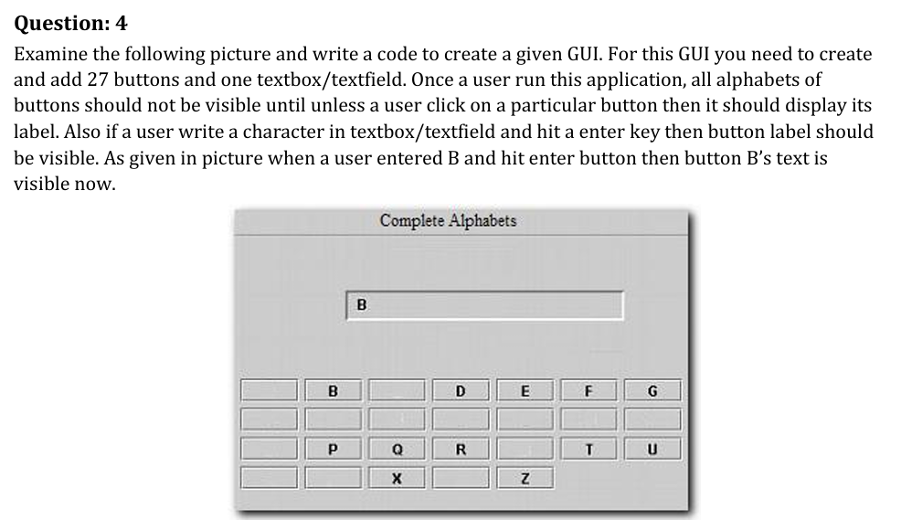

Code

import javax.swing.*;

import java.awt.*;

import java.awt.event.*;

import java.util.HashMap;

public class Task4 {

public static void main(String[] *args*) {

JFrame frame = new JFrame("Complete Alphabets");

JTextField textField = new JTextField();

textField.setBounds(100, 50, 200, 30);

frame.add(textField);

JPanel panel = new JPanel();

panel.setLayout(new GridLayout(4, 7, 5, 5));

panel.setBounds(20, 100, 360, 160);

HashMap<Character, JButton> buttons = new HashMap<>();

for(char c = 'A'; c <= 'Z'; c++) {

JButton button = new JButton("");

char letter = c;

button.addActionListener(new ActionListener() {

public void actionPerformed(ActionEvent *e*) {

button.setText(String.valueOf(letter));

}

});

buttons.put(c, button);

panel.add(button);

}

textField.addActionListener(new ActionListener() {

public void actionPerformed(ActionEvent *e*) {

String input = textField.getText().toUpperCase();

if(input.length() == 1) {

char ch = input.charAt(0);

if(buttons.containsKey(ch)) {

buttons.get(ch).setText(String.valueOf(ch));

}

}

}

});

frame.add(panel);

frame.setSize(420, 350);

frame.setLayout(null);

frame.setVisible(true);

frame.setDefaultCloseOperation(JFrame.EXIT_ON_CLOSE);

}

}

Output

